School Improvement Plan

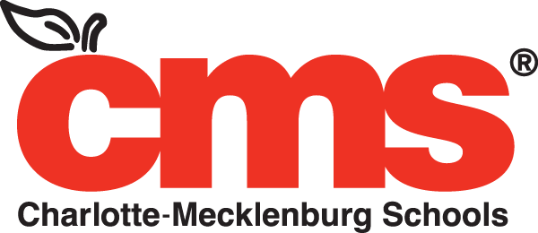

2017-2018

School Improvement Plans remain in effect for two years, but a School Leadership Team may amend as often as necessary or appropriate.

Allenbrook Elementary Contact Information
School: | Allenbrook Elementary School | Courier Number: | 308
Address: | 1430 Allenbrook Drive | Phone Number: | 980-343-6004
 | Charlotte, NC 28208 | Fax Number: | 980-343-6115
Learning Community | Project L.I.F.T. | School Website: | http://schools.cms.k12.nc.us/allenbrookES/Pages/Default.aspx

Principal: | Katharine Bonasera
Learning Community Superintendent: | Denise Watts

Allenbrook Elementary School Improvement Team Membership
From GS §115C-105.27: “The principal of each school, representatives of the assistant principals, instructional personnel, instructional support personnel, and teacher assistants assigned to the school building, and parents of children enrolled in the school shall constitute a school improvement team to develop a school improvement plan to improve student performance. Representatives of the assistant principals, instructional personnel, instructional support personnel, and teacher assistants shall be elected by their respective groups by secret ballot....Parents serving on school improvement teams shall reflect the racial and socioeconomic composition of the students enrolled in that school and shall not be members of the building-level staff.”
Committee Position | Name | Email Address | Date Elected
Principal | Katharine Bonasera | Katharineb.bonasera@cms.k12.nc.us | 8/29/17
Assistant Principal Representative | Xzaviar Bailey | Xzaviar.bailey@cms.k12.nc.us | 8/29/17
PK-1 Teacher Representative | Bridget Walls | Bridgett.walls@cms.k12.nc.us | 8/29/17
PK-1 Teacher Representative | Ashley Robinson | Ashleys.robinson@cms.k12.nc.us | 8/29/17
2-3Teacher Representative | Imogen Thomas-Williams | Imogen.thomas-williams@cms.k12.nc.us | 8/29/17
2-3Teacher Representative | Michael Roper | Michael.roper@cms.k12.nc.us | 8/29/17
4-5 Teacher Representative | Christopher Moses | Christopher.moses@cms.k12.nc.us | 8/29/17
4-5 Teacher Representative | Artrice Johnson | Artrice1.johnson@cms.k12.nc.us | 8/29/17
Inst. Support Representative | Elizabeth Bertke | Elizabetha.bertke@cms.k12.nc.us | 8/29/17
Teacher Assistant Representative | Jennifer Sale | Jenniferl.sale@cms.k12.nc.us | 8/29/17
Student Supports Representative | Carla Gaymon | Carla1.gaymon@gmail.com | 8/29/17
Community Representative | Gerri Wallace |  | 8/29/17
Parent Representative | Priscilla Brewer | Priscilla.brewer@cms.k12.nc.us | 8/29/17

Vision Statement
District: CMS provides all students the best education available anywhere, preparing every child to lead a rich and productive life.
School: Allenbrook provides all students an education which helps them grow personally, contribute to the school and advance our community.
Mission Statement
District: The mission of CMS is to maximize academic achievement by every student in every school.
School: Learning for All, Whatever It Takes
Allenbrook Elementary Shared Beliefs

“Ignite. Innovate. Iterate” We will ignite a love of learning and build community through consistent, positive, and energetic interactions. We will innovate by using data to drive personalized instruction and valuing creativity in our students and staff. We will iterate by focusing on continuous improvement for children through mastery learning and adults through action oriented observation and feedback

Allenbrook Elementary SMART Goals
- Provide a duty-free lunch period for every teacher on a daily basis, to the maximum extent that the safety and proper supervision of students may allow during regular student contact hours.
- Provide duty-free instructional planning time for every teacher under G.S. 115C-105.27 and -301.1, with the goal of proving an average of at least five hours of planning time per week, to the maximum extent that the safety and proper supervision of students may allow during regular student contact hours.
- Provide a positive school climate, under CMS regulation JICK-R, by promoting a safe learning environment free of bullying and harassing behaviors.
- Develop, strengthen, and maintain an academic culture focused on consistent, high quality instruction which balances rigorous standards, aligned content, and student-centered pedagogy in order to accelerate student achievement to provide students access to unlimited opportunities.
- Develop, strengthen, and maintain an aligned school culture rooted in trust, communication, high expectations, and consistency for students, staff, and families in order to create a safe, joyful, and transformational learning environment.

Allenbrook Elementary Assessment Data Snapshot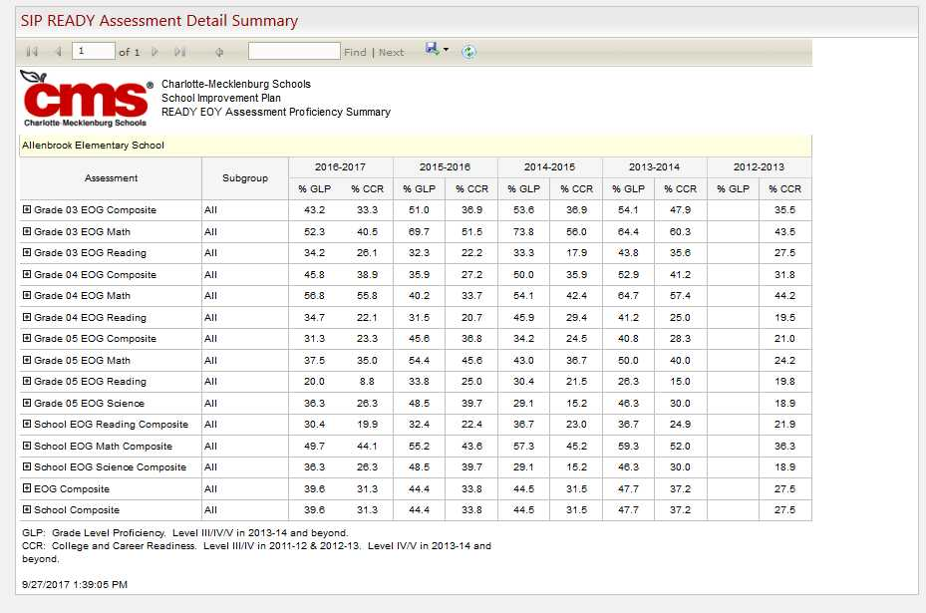
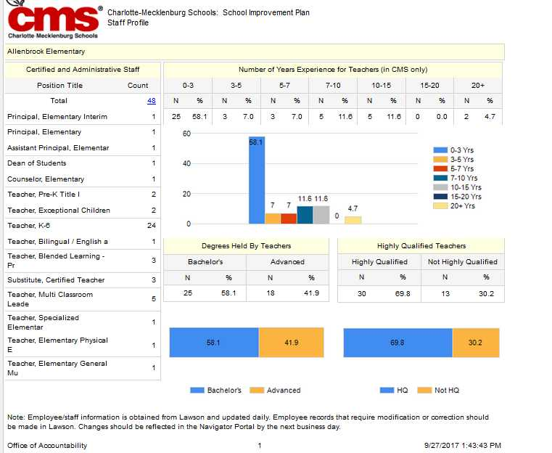
Allenbrook Elementary Profile
Allenbrook Elementary is a small school nestled in a quiet neighborhood located in the western part of Mecklenburg County. The historical information for Allenbrook dates back to 1957. Allenbrook is part of the Project LIFT Learning Community. Allenbrook Elementary School is a Title I school that currently serves approximately 600 students in pre-kindergarten through fifth grade. Of these students 72.2% are African American, 12.1% are Latino/Hispanic, 3.2% are white, 10.2% are Asian, 7.9% American Indian and .4% Native Hawaiian/Pacific. At Allenbrook, approximately 78% of students are identified under CEP, 10.8 are LEP, 11.3 are classified EC and 1.1% are academically gifted.

We have 2 pre-kindergarten, 4 kindergarten, 4 first grade, 5 second grade, 5 third grade, 4 fourth grade, and 4 fifth grade classrooms. Our average class size is 22. The school follows a traditional school calendar. Regular instruction for students begins at 7:45 and ends at 2:45PM. Allenbrook has a small group of students who walk to school; however, the majority of the students are bused in from a home school zone made up of nearby neighborhoods and apartment complexes.

Allenbrook Elementary School became part of a district and non-profit partnership Project LIFT, in which all member schools are feeder schools to West Charlotte High School. The administrative team includes a principal, assistant principal, and dean. In addition to our administrative team, we have four multi-classroom leaders working to coach, support, and develop the effectiveness of classroom teachers. We have numerous individuals on staff to support our pre-kindergarten through fifth grade students, including a school counselor, social worker, ESL teacher, TD teacher, two EC teachers, and a speech pathologist. Our behavior management technician helps support the behavior needs of our students across all grade levels. There are twenty-two classroom teachers on staff as well as four Reach Associates, two pre-kindergarten assistants, and two teacher assistants. Our students engage in Connect special area classes daily. To support this we have an art teacher, physical education teacher, and a music teacher. 100% of our staff members are highly qualified and dedicated to meeting the needs of our students.

In the 2015-2016 school year teachers at Allenbrook worked in Professional Learning Communities to increase their effectiveness and support each other in meeting the needs of students. Data Driven Instruction serves as a foundation for this process. A variety of data sources are considered including EOG results, common assessments, Reading 3D, and Discovery Education assessments. During the 2017-2018 school year, we will utilize common assessments, Reading 3D, Discovery Education assessments, and EOG results. Teachers meet in PLCs to write SMART goals for their students based on past performance and diagnostic data. They, then, plan instruction to address these goals.

Teachers regularly assess their students using formal and informal measures. This provides them with feedback to monitor and adjust their instruction based on student work. We utilize the CMS early release days to conduct deep data analysis and action planning, which allow for teachers to view the grade level as a whole and within classes. During these times, teachers analyze the most recent data from a common assessment and write up action plans to meet student needs. Data conversations continue to take place on a weekly basis during planning. In addition to the deep dive data meetings, teachers participate in 165 minute curriculum planning each week. During this time they discuss specific instructional strategies that can be used to meet learning objectives and work with MCLs to generate new ideas for instruction.

For students that need additional support to meet their academic and social needs, Allenbrook has designed a new MCL1 position to create manageable, intensive plans for these subgroups of students. Any student that is more than two years behind, ESL, EC, or has started the intervention process will be targeted for these interventions and their progress monitored by teachers and the MCL1. Our pre-k teachers collaborate with our kindergarten staff to ensure that students with increased need transition smoothly from pre-kindergarten to kindergarten. Additionally, our counselor works closely with middle school staff to transition our fifth grade students. Through this process our students are able to get the support they need to meet their fullest potential.

This year teachers will continue their own professional development to impact student learning. Our professional development focus for the 2016-2017 school year includes No Nonsense Nurturer, utilizing data to drive instruction, Core Knowledge & Expeditionary Learning training, incorporating technology, and cultural proficiency. Teachers will continue to receive professional development in the use of ongoing assessment tools such as Reading 3D to enhance their instruction. These professional development opportunities will assist classroom teachers in showing students how to transfer and apply knowledge while enhancing learning opportunities in all subject areas. Our 4 MCLs and lead team members per grade are also instrumental in coaching and developing our teachers. They provide regular feedback, conduct learning walks and co-teach lessons. They utilize teacher-level data to target classrooms that need the most support and provide extra mentoring for beginning teachers.

Our academic program is focused on preparing students to be successful in middle school, high school, and beyond. Literacy serves as the foundation of the academic program and every grade level has at least 120 minutes for literacy instruction per day. Teachers utilize a balanced literacy approach to meet the needs of students. They utilize Core Knowledge and Expeditionary Learning in reading. During some of this time teachers have additional support from reach associates, EC teachers, ESL teachers and MCLs. Students have time for independent reading and writing during small group instruction. They self-select reading materials that will help them reach individual reading goals. Math instruction is focused on building conceptual understanding of basic math concepts. Teachers utilize Eureka Math. Every grade level has at least 90 minutes for math instruction. Incorporated into this time is math workshop where students are ability grouped to practice skills they need based on data. Science and Social Studies are integrated into literacy curriculum. 4th and 5th grade students have 45 minutes of Science. Labs are incorporated to enhance core instruction. Teachers work to integrate literacy across these content areas to continue to build a strong foundation of literacy in students.

At Allenbrook our staff works to create a positive and nurturing school environment. We hold quarterly awards assemblies to honor student academic progress. We hold “Hive Huddles” focused on character development and promoting a love of reading. We have several programs for students to develop leadership qualities. Allenbrook News Network is our student run closed-circuit TV station. Students also have the opportunity to serve on Girls on the Run, Safety Patrol, Color Guard, and Step Team.

Parental support is an important part of our school. We maintain open communication with parents through regular newsletters, ConnectEd messages, conferences and events. Parents are encouraged to join our School Leadership team. We are relaunching our Parent Teacher Association this year. Through these organizations they provide input on school policies, help plan events, volunteer and engage with the school community as a whole. In 2015-2016 we saw tremendous turnout for Back to School Night, Black History Program, and the International Festival. These events will continue this year. In addition, school committees plan several other events throughout the year to increase parental involvement. We look forward to increasing opportunities for parents to engage in the learning process moving forward.

Community partners join with the school to help meet the academic and social needs of the students. We are currently working with one of the districts Community Partnerships & Family Engagement Coordinator to help us build partnerships and have a growing partnership with Durham Memorial Baptist Church and Christ Resurrection Church. We also have a Community in Schools site coordinator at the school who also helps with building community partners. In addition, we are also partnered with A Child’s Place and Kids with Incarcerated Parents to help meet the needs of our students. Many teachers at Allenbrook take advantage of Donor’s Choose to get some of the supplies they need for their classrooms. Of course, we cannot forget to include the businesses that have partnered with Project LIFT, which directly impacts our school. In 2016-2017 we will continue to develop these partnerships and expand our impact.

We are excited about the progress at Allenbrook Elementary School and the direction we are headed. Over the course of the next year our goal is to ensure that each and every student that walks through our doors is receiving an excellent education, focused on individual needs. It is important that we continue to grow our teachers through professional development and leadership opportunities. We look forward to strengthening our parental involvement and community partnerships to ensure we are addressing the social and emotional needs of our students. Though we face many challenges and our students are still behind their middle class peers academically, we are committed to overcoming the obstacles and closing the achievement gap. Every child deserves access to an education that will prepare them to accomplish any goal they set and be prepared to be productive citizens.

Strategic Plan 2019: For a Better Tomorrow
Goal 1: Maximize academic achievement in a personalized 21st-century learning environment for every child to graduate college- and career-ready  Four focus areas:  - College- and career-readiness  - Academic growth/high academic achievement  - Access to rigor  - Closing achievement gaps | Goal 2: Recruit, develop, retain and reward a premier workforce  Five focus areas:  - Proactive recruitment  - Individualized professional development  - Retention/quality appraisals  - Multiple career pathways  - Leadership development
Goal 3: Cultivate partnerships with families, businesses,  faith-based groups and community organizations to provide a sustainable system of support and care for each child  Three focus areas:  - Family engagement  - Communication and outreach  - Partnership development | Goal 4: Promote a system-wide culture of safety, high engagement, cultural competency and customer service  Five focus areas:  - Physical safety  - Social and emotional health  - High engagement  - Cultural competency  - Customer service
Goal 5: Optimize district performance and accountability by  strengthening data use, processes and systems  Four focus areas:  - Effective and efficient processes and systems  - Strategic use of district resources  - Data integrity and use  - School performance improvement | Goal 6: Inspire and nurture learning, creativity, innovation and entrepreneurship through technology and strategic school redesign  Four focus areas:  - Learning everywhere, all the time  - Innovation and entrepreneurship  - Strategic school redesign  - Innovative new schools

SMART Goal (1):  Duty Free Lunch for Teachers | Provide a duty-free lunch period for every teacher on a daily basis.
Strategic Plan Goal: | Goal 2: Recruit, develop, retain and reward a premier workforce  Goal 4: Promote a system-wide culture of safety, high engagement, cultural competency and customer service
Strategic Plan Focus Area: | Teacher Retention; Customer Service
Data Used: | Discipline reports, InSight Survey results

Strategies (determined by what data)  - Task  - Task (PD) | Point Person  (title/name) | Evidence of Success  (Student Impact) | Funding  (estimated cost / source) | Personnel Involved | Timeline  (Start—End)  Interim Dates
1. Lunch coverage will be provided by teachers, administrators, and support staff | Principal,-Bonasera,  Assistant Principal-  Bailey  MCLs-  Bertke, Moses, Roper, Mohler, T-W, Robinson, Walls | -Decrease number of student  discipline referrals/OSS  -Increase learning environment noted on InSight Survey | CMS | Admin | September-June  - 10/28/17  - 1/23/18  - 3/30/18
2. Assigned Seating: Students will be assigned seats through a seating chart devised by the classroom teacher to minimize behavior issues and facilitate behavior management by lunch monitors. | Classroom Teachers | -Decrease number of student discipline referrals/OSS  -Increase learning environment noted on InSight Survey. | N/A | Classroom Teachers | September-June  - 10/28/17  - 1/23/18  - 3/30/18
3. Master Schedule: The schedule for lunches has been arranged to manage the number of students in the cafeteria at any given time. | Principal,-Bonasera,  Assistant Principal-  Bailey  ILT-Walls, Robinson, T-W, Mohler, Moses, Roper, Bertke  Dean-Gwinn  Cafeteria Mgr-Hamilton | -Decrease number of student discipline referrals/OSS  -Increase learning environment noted on InSight Survey. | N/A | Admin | September-June  - 10/28/17  - 1/23/18  - 3/30/18
4. School Behavior Hierarchy: Will be posted throughout the school and cafeteria to set clear behavioral expectations for students and incentives for positive behaviors. | SST (Gwinn, Medley, Curran)  Admin Bonasera | Decrease number of student discipline referrals/OSS  -Increase learning environment noted on InSight Survey. | N/A | SST (Gwinn, Medley, Curran)  Lunch Monitor  Admin Bonasera | September-June  - 10/28/17  - 1/23/18  - 3/30/18

SMART Goal (2):  Duty Free Instructional Planning Time | Provide duty-free instructional planning time for every teacher under G.S. 115C-105.27 and -301.1, with the goal of proving an average of at least five hours of planning time per week, to the maximum extent that the safety and proper supervision of students may allow during regular student contact hours.
Strategic Plan Goal: | Goal 2. Recruit, develop, and retain a premier workforce.  Goal 4: Promote a system-wide culture of safety, high engagement, cultural competency and customer service
Strategic Plan Focus Area: | Professional Development, Retention, Leadership, Communication
Data Used: | InSight Survey, assessment data

Strategies (determined by what data)  - Task  - Task  - Task (PD) | Point Person  (title/name) | Evidence of Success  (Student Impact) | Funding  (estimated cost / source) | Personnel Involved | Timeline  (Start—End)  Interim Dates
1. Master Schedule: Create allowing duty-free instructional planning for every teacher for 55 minutes daily. | Principal Bonasera  Assistant Principal  Bailey | -Increase learning environment noted on InSight Survey.  -Increase in student achievement. Master Schedule, Team Minutes, Classroom Observations Minutes | N/A | Classroom Teachers  Connect Teachers  MCL’s  Admin | September-June  - 10/28/17  - 1/23/18  - 3/30/18
2. Provide class coverage: Connect team covers classroom teachers 55 minutes daily. | Principal Bonasera  Assistant Principal  Bailey | -Increase learning environment noted on InSight Survey  -Increase in student achievement. | N/A | Classroom Teachers  Connect Teachers  MCL’s  Admin | September-June  - 10/28/17  - 1/23/18  - 3/30/18
3. Maximize learning effectiveness through training grade level chairs, Planning/Data meetings, establishing planning agendas, effective leadership strategies. Participate in curriculum “deep dives with MCL’s. | Principal Bonasera  Assistant Principal  Bailey | -Increase learning environment noted on InSight Survey  -Increase in student achievement.  -Team Norms and agendas, Admin Meetings, Observational Data | N/A | Classroom Teachers  Connect Teachers  MCL’s  Admin | September-June  - 10/28/17  - 1/23/18  - 3/30/18
4. Establish/utilize new means of communication: Buzz-online staff newsletter, emails in place of meetings, Google Docs-coaching, comments, collaboration to allow planning to focus on instruction. | Principal Bonasera  Assistant Principal  Bailey  ILT- Walls, Robinson, T-W, Mohler, Roper, Bertke, Moses | -Increase learning environment noted on InSight Survey  -Increase in student achievement.  -Copies of weekly staff newsletters and Google Coaching document | N/A | Admin | September-June  - 10/28/17  - 1/23/18  - 3/30/18

SMART Goal (3):  Anti-Bullying / Character Education | Provide a positive school climate, under CMS regulation JICK-R, by promoting a safe learning environment free of bullying and harassing behaviors.
Strategic Plan Goal: | Goal 4: Promote a system-wide culture of safety, high engagement, customer service and cultural competence.
Strategic Plan Focus Area: | Physical Safety, High Engagement, Cultural Competency, Social and Emotional Health.
Data Used: | InSight Survey, assessment data, suspension numbers

Strategies (determined by what data)  - Task  - Task  - Task (PD) | Point Person  (title/name) | Evidence of Success  (Student Impact) | Funding  (estimated cost / source) | Personnel Involved | Timeline  (Start—End)  Interim Dates
1. Bully Liaison / Bully-prevention | Admin Bonasera  Social Worker  Curran  Medley  Dean Gwinn | Decrease in suspensions  Higher attendance  Decrease in the number of reported bullying cases | N/A | Principal Bonasera  Assistant Principal  SST-Medley, Gwinn, Curran  SLT  Members  Discipline/Behavior Committee | September-June  - 10/28/17  - 1/23/18  - 3/30/18
- No Nonsense Nurturer to establish school wide expectations. | Admin  Bonasera,  Counselor Medley  Dean Gwinn | Increase in rewards for positive behavior  Decrease in suspensions  Higher attendance | N/A | Principal Bonasera  Assistant Principal  SST-Medley, Gwinn, Curran  SLT  Members  Discipline/Behavior Committee | September-June  - 10/28/17  - 1/23/18  - 3/30/18
- Character Education  - Hive Huddle  - School Store for incentives | Admin Bonasera  Social Worker  Curran  Medley  Dean Gwinn | Increase in rewards for positive behavior  Decrease in suspensions  Higher attendance | N/A | SST  BMT | September-June  - 10/28/17  - 1/23/18  - 3/30/18
- Individual and small group counseling | Admin Bonasera  Social Worker  Curran  Medley  Dean Gwinn | Increase in rewards for positive behavior  Decrease in suspensions  Higher attendance | N/A | SST  BMT | September-June  - 10/28/17  - 1/23/18  - 3/30/18
- Healthy Active Child 30 min.  - Implement moderate to rigorous 30 minute structured physical activity daily in all classrooms  - Implement 55 minutes per week with the certified PE Teacher  - PE Teachers will support classroom teachers by providing guidance and ideas on activities and athletic equipment | Admin Bonasera,  PE Teacher, Lake | Increase in rewards for positive behavior  Decrease in suspensions  Increase attendance | N/A | Admin Bonasera,  PE Teachers  All teachers | September-June  - 10/28/17  - 1/23/18  - 3/30/18
- School Health Team  - Establish a school Health Advisory Committee-Action for Healthy Eating  - The committee will plan, implement and monitor the implementation of the health food plan  - The committee will meet monthly as part of SLT | Admin Bonasera,  School Nurse  Russell  Cafeteria Manager Hamilton  Social Worker Curran | Increase attendance  Increase in positive behavior  Increase in engagement and achievement  Decrease in suspensions | N/A | Admin Bonasera,  School Nurse  Satterfield  Cafeteria Manager Hamilton  Social Worker Curran | September-June  - 10/28/17  - 1/23/18  - 3/30/18

SMART Goal (4):  Instructional Culture | Develop, strengthen, and maintain an academic culture focused on consistent, high quality instruction which balances rigorous standards, aligned content, and student-centered pedagogy in order to accelerate student achievement to provide students access to unlimited opportunities.
Strategic Plan Goal: | Goal 1: Maximize academic achievement in a personalized 21st-century learning environment for every child to graduate college- and career-ready  Goal 5: Optimize district performance and accountability by  strengthening data use, processes and systems  Goal 6: Inspire and nurture learning, creativity, innovation and entrepreneurship through technology and strategic school redesign
Strategic Plan Focus Area: | Increase accountability; identify and leverage validating data points; use various strategies to sustain energy.
Data Used: | Dibels, TRC, BOG, MAP Diagnostic

Strategies (determined by what data)  See 90-Day Plan  - Task  - Task  - Task (PD) | Point Person  (title) | Evidence of Success  (Student Impact) | Funding  (estimated cost / source) | Personnel Involved | Timeline  (Start—End)  - Interim Dates
1.

SMART Goal (5):  School Culture/ Staff Culture | Develop, strengthen, and maintain an aligned school culture rooted in trust, communication, high expectations, and consistency for students, staff, and families in order to create a safe, joyful, and transformational learning environment.
Strategic Plan Goal: | Goal 2: Recruit, develop, retain and reward a premier workforce  Goal 4: Promote a system-wide culture of safety, high engagement, cultural competency and customer service
Strategic Plan Focus Area: | Increase accountability; identify and leverage validating data points; and use various strategies to sustain energy.
Data Used: | Staff Survey Data, Staff Attendance Data, Student Culture Data

Strategies (determined by what data)  - Task  - Task  See 90-Day Plan  - Task (PD) | Point Person  (title) | Evidence of Success  (Student Impact) | Funding  (estimated cost / source) | Personnel Involved | Timeline  (Start—End)  - Interim Dates
1.
2.

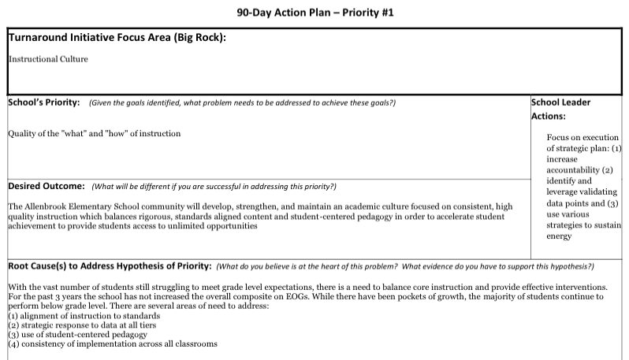

Strategies (determined by what data)  - Task  - Task  - Task (PD) | Point Person  (title) | Evidence of Success  (Student Impact) | Funding  (estimated cost / source) | Personnel Involved | Timeline  (Start—End)  - Interim Dates
1. |  |  | See Comprehensive Plan
2.
3.

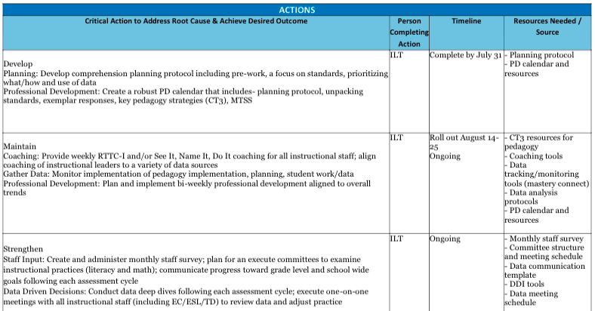
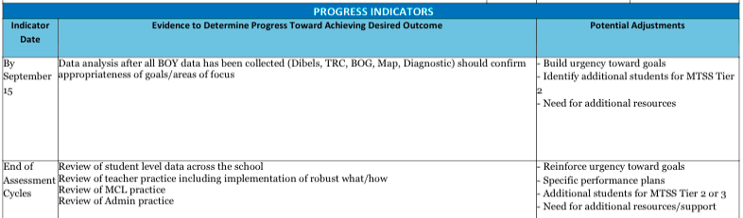

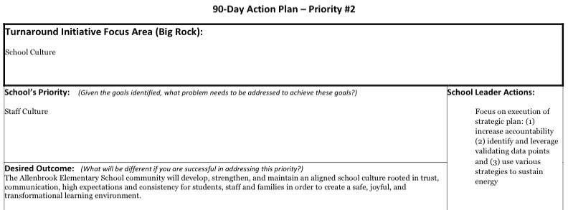

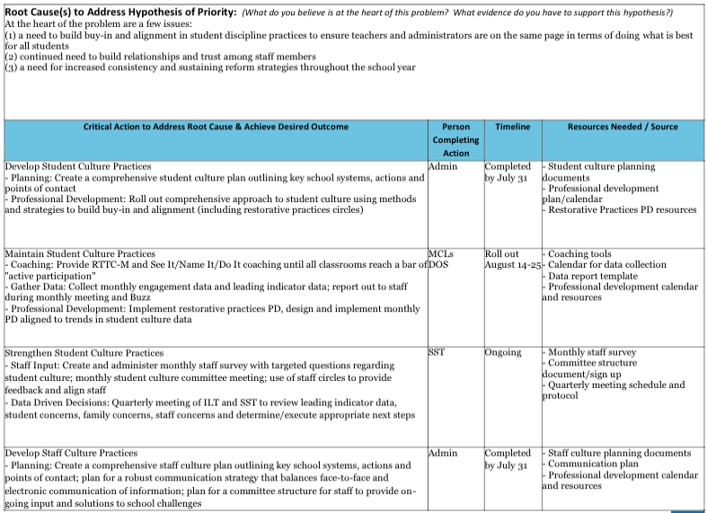
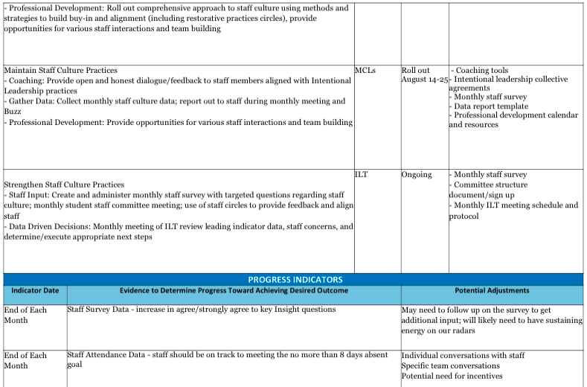

SMART Goals:
Strategic Plan Goal:
Strategic Plan Focus Area:
Data Used:

Strategies (determined by what data)  - Task  - Task  - Task (PD) | Point Person  (title) | Evidence of Success  (Student Impact) | Funding  (estimated cost / source) | Personnel Involved | Timeline  (Start—End)  - Interim Dates
1. |  |  | See Comprehensive Plan
2.

Mastery Grading Procedures Plan – Required for All Schools
Strategic Plan Goal: | Goal 1: Maximize academic achievement in a personalized 21st-century learning environment  for every child to graduate college- and career-ready.
Strategic Plan Focus Area: | Academic growth/high academic achievement
Data Used: | Formative assessment data, report card data

Strategies (determined by what data)  - Task  - Task  - Task (PD) | Point Person  (title/name) | Evidence of Success  (Student Impact) | Funding  (estimated cost / source) | Personnel Involved | Timeline  (Start—End)  Interim Dates
1. Common assessments  - Pre and Post assessments created using School Net or other; aligned with objective given every six weeks | MCL’s  Walls, Robinson, Thomas-Williams, Moses, Roper and Bertke | Student achievement growth on assessed objectives | N/A | Teachers  EC Teachers  MCL’s Walls, Robinson, Thomas-Williams, Moses, Roper and Bertke  Admin | September-June  - 10/28/17  - 1/23/18  - 3/30/18
2. Data disaggregation  - Process of monitoring student achievement by objective in order to facilitate remediation/intervention plans (i.e. RTI) | MCL’s Walls, Robinson, Thomas-Williams, Moses, Roper and Bertke  Admin Bonasera | Decrease in Intervention Team referrals | N/A | MCL’s Walls, Robinson, Thomas-Williams, Moses, Roper and Bertke  Admin Bonasera | September-June  - 10/28/17  - 1/23/18  - 3/30/18
3. Flexible grouping  - Students will be grouped according to academic need by objective | MCL’s Walls, Robinson, Thomas-Williams, Moses, Roper and Bertke  Admin Bonasera | Student achievement  growth | N/A | MCL’s Walls, Robinson, Thomas-Williams, Moses, Roper and Bertke  Admin Bonasera | September-June  - 10/28/17  - 1/23/18  - 3/30/18
4. Late and make-up work  - Students will be re-taught and reassessed with a goal of 84% mastery  - School expectations for holding students accountable for completing assignments | MCL’s Walls, Robinson, Thomas-Williams, Moses, Roper and Bertke  Admin Bonasera | -Student achievement  Growth  -Students will be held accountable for their learning  -Increase in completion rate of assignments | N/A | MCL’s Walls, Robinson, Thomas-Williams, Moses, Roper and Bertke  Admin Bonasera  All teachers | September-June  - 10/28/17  - 1/23/18  - 3/30/18
5. Grade Reporting  - Set expectations for the timeliness of recording grades in PowerSchool (initial grades and final grades after retest where applicable) | Admin and  MCL’s Walls, Robinson, Thomas-Williams, Moses, Roper and Bertke  Admin Bonasera | Increase of parental  involvement | N/A | Teachers  EC Teachers  Admin and  Facilitators | September-June  - 10/28/17  - 1/23/18  - 3/30/18
6. Grading Scale  - Use 10 point grading scale to determine final grades | MCL’s  Walls, Robinson, Thomas-Williams, Moses, Roper and Bertke  Admin Bonasera | Increase in students receiving As, Bs, Cs, and Ds  Increase in alignment between grades, common interim assessments and EOG proficiency | N/A | Teachers  EC Teachers  MCL’s Walls, Robinson, Thomas-Williams, Moses, Roper and Bertke  Admin | September-June  - 10/28/17  - 1/23/18  - 3/30/18

Allenbrook Elementary - 600 Waiver Requests
Request for Waiver
1. Insert the waivers you are requesting
- Maximum Teaching Load and Maximum Class Size (grades 4-12) [required for all schools with grades 4-12]
2. Please identify the law, regulation or policy from which you are seeking an exemption.
- 115C-301 (c and d) Maximum Teaching Load and Maximum Class Size [required for all schools with grades 4-12]
3. Please state how the waiver will be used.
- Class size will be adjusted to address student individual instructional needs through flexible grouping of students in the most effective utilization of teaching teams. Maximum teaching load will be used to allow teachers in specific areas of the curriculum to teach students designated for specific skill needs and to address the large number of students requesting elective classes.
- Please state how the waiver will promote achievement of performance goals.

- This waiver will allow more flexibility in grouping students to meet their abilities and needs and thus should enhance their achievement on the performance goals.

