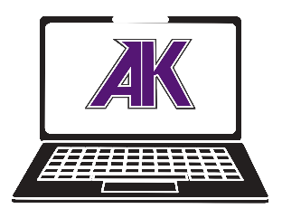
Chromebook Damage Fees
Online Payment Instructions

Student Name:
Student ID:
Grade Level:
*Please use this information to assist you with paying for Chromebook Damage Fees online through Online School Payment (OSP). Failure to pay for fees assigned to your student account will result in not being allowed to participate in extra school based activities, loss of parking spot, diploma being held, or other consequences.
Type of Damage
 | Missing Keys |  | Bent, Cracked, Broken Chassis
 | Spills, Liquid Damage |  | Broken or Missing Charger
 | Scratched, Cracked, Punctured Screen |  | Scratched, Cracked, Punctured Webcam
 | Scratched Touchpad |  | Damaged Microphone
 | Missing AK or CMS Label(s) |  | Non-school based Stickers or Labels
 | Missing, Entirely Damaged Chromebook |  | Other
Explanation:

Cost of Damage
 | Missing Keys ($15) |  | Keyboard Replacement ($15)
 | Screen Damage ($15) |  | Charger Replacement ($10)
 | Chromebook Replacement ($50) |  | Miscellaneous ($5)  *As determined by Tech Staff only*
How to Pay
Go to Ardrey Kell HS’s website=>Click on Online School Payments on the left=>Click on Chromebooks=>Use the info above to check the proper items=>Submit payment=>Keep email for your records=>You do not need to email the school; we will see it and clear your record.
Questions? Email Mr. Wilson: brandond.wilson@cms.k12.nc.us
Revised: August 2022

